AM 24 EXERCISE 2 – Predator/Prey

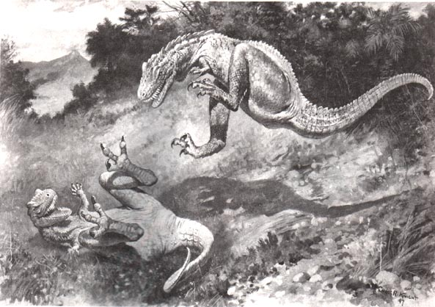

System to build
Extend the system built in exercise 1: The prey search for food to eat in the environment. The preys are organized into flocks, which move together in the environment. The predators hunt together in smaller groups, in which they communicate prior to captures. The communication range of the predators is limited.

Questions to answer
- Briefly analyse the problem of the exercise from a MAS perspective.
- Extend your MAS system from exercise 1 in MadKit based on your analysis.
- Experiment with the properties of the agents and how they affect convergence:
  - Communication range of the predators.
  - Visibility range of the prey.
  - Visibility range of the predators.
  - The ratio of the speed of predators/prey.
- Experiment with the parameters of the world and how they affect convergence:
  - The amount of food available in the environment and its spread.
  - Size of the world.
  - Number of predators/preys in the world and the ratio.
  - The world being a torus or not.

